Functional Specification

Homepage

Table of Contents

1 PERMISSION CONTROL 2

2 PAGE STRUCTURE 2

3 BURGER MENU & TOP NAVIGATION 2

3.1 Burger Menu 2

3.2 Top Navigation Icons 3

4 PAGE HEADER 4

4.1 Header Content 4

4.2 Content Maintain 5

4.3 Update Panel 5

4.4 Scroll Prompt 5

5 TILES 6

5.1 Hover the tiles 6

5.2 Fixed and dynamic background image 7

5.3 Tile’s link 7

6 AGENCY SPOTLIGHT CAROUSEL 8

7 BRAND SUPPORT PANEL 9

8 WHAT ARE DIFFERENCES BETWEEN OUR WORK AND OMOBONO’S DESIGN 9

# PERMISSION CONTROL

* All login users can view this page

# PAGE STRUCTURE

Homepage is consist of below sections:

* Header
* Tiles
* Agency spotlight
* Brand support team and hotline
* Footer

# PAGE HEADER

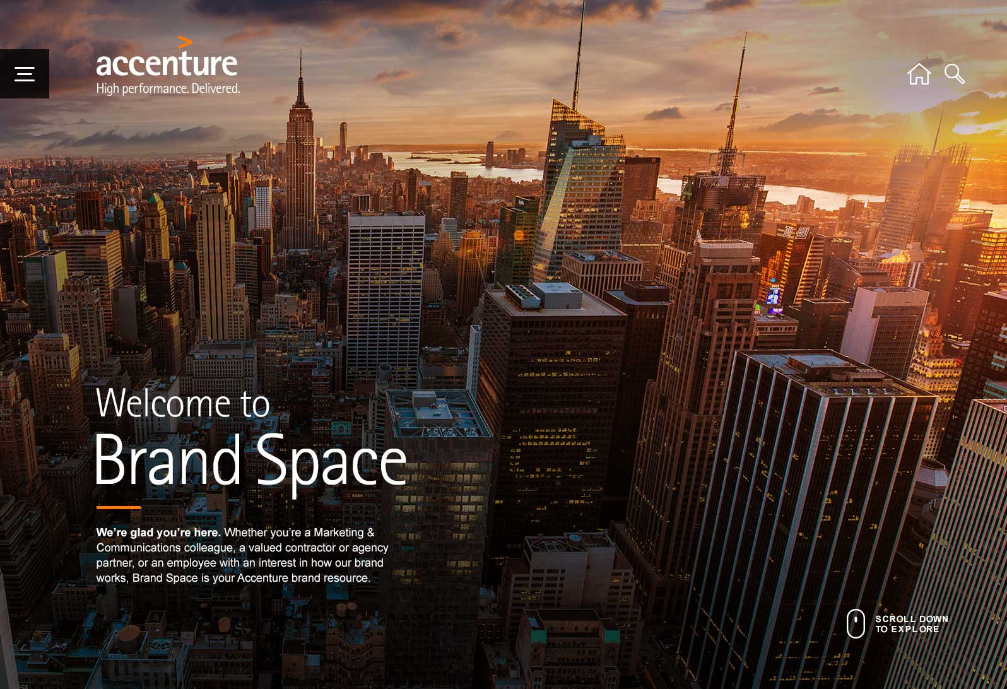

## Header Content

* Page header is consist of 5 parts:

① Background image  
② Top title  
③ Main title  
④ Description  
⑤ Scroll prompt  
⑥ Update Panel

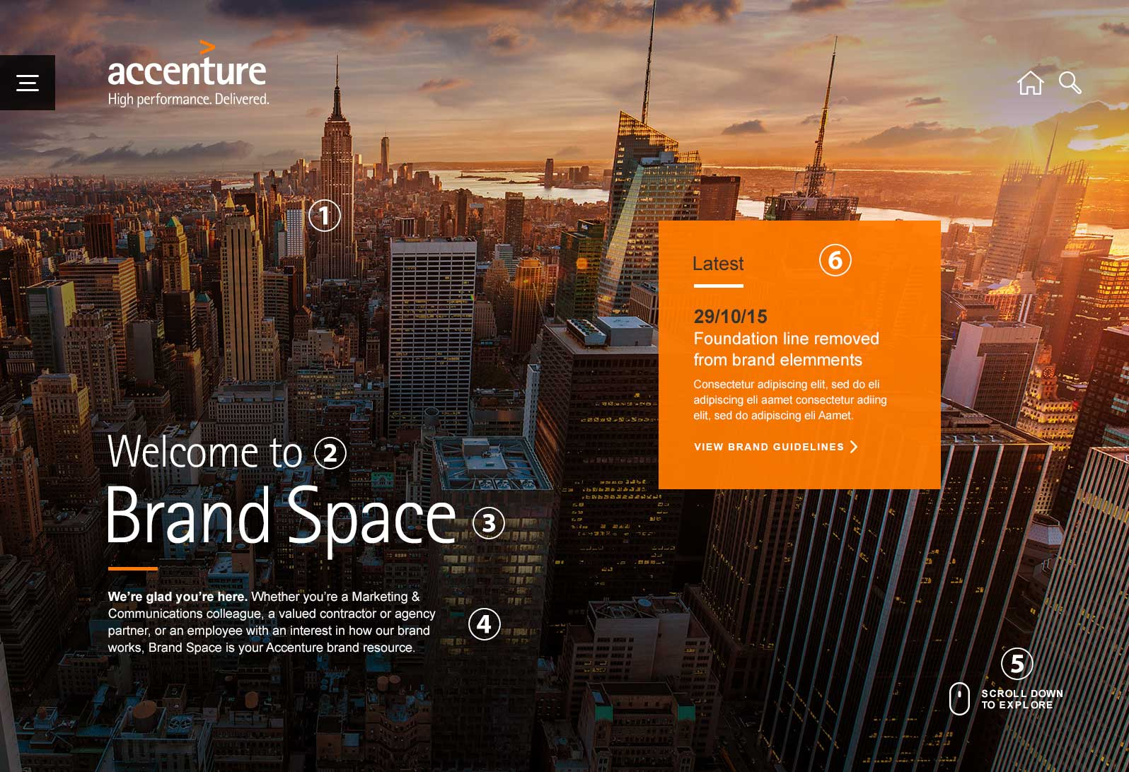

* Except the background image, all of other parts have a transition in effect(with animation)

## Content Maintain

In the backend, Brand team can upload new picture for the background image, set the texts and color for titles and description, and the Update Panel content

## Update Panel

Update panel is consist of 4 parts:

* Date
* Title
* Details(with hyperlinks)
* Edit Icon (only be shown for Brand team members)  
  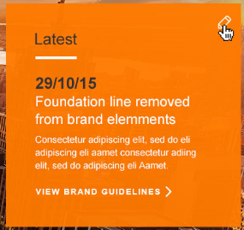

For Brand team members, when there is no update information in the Update Panel, there will be a plus icon to allow Brand team member add new update information(Hover the icon will show a tooltip “CLICK TO ADD AN UPDATE”), click this icon will go to backend to add new update information. Normal users will not see this icon



For Brand team members, when there is an existing update, an edit icon is shown in the panel, click it will go to backend to edit update information.  
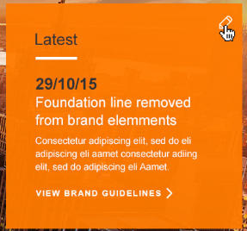

## Scroll Prompt

As the header is a full screen size, so the scroll prompt icon will be shown when the page loaded initially. When user starts to scroll, this icon will be disappear

# TILES

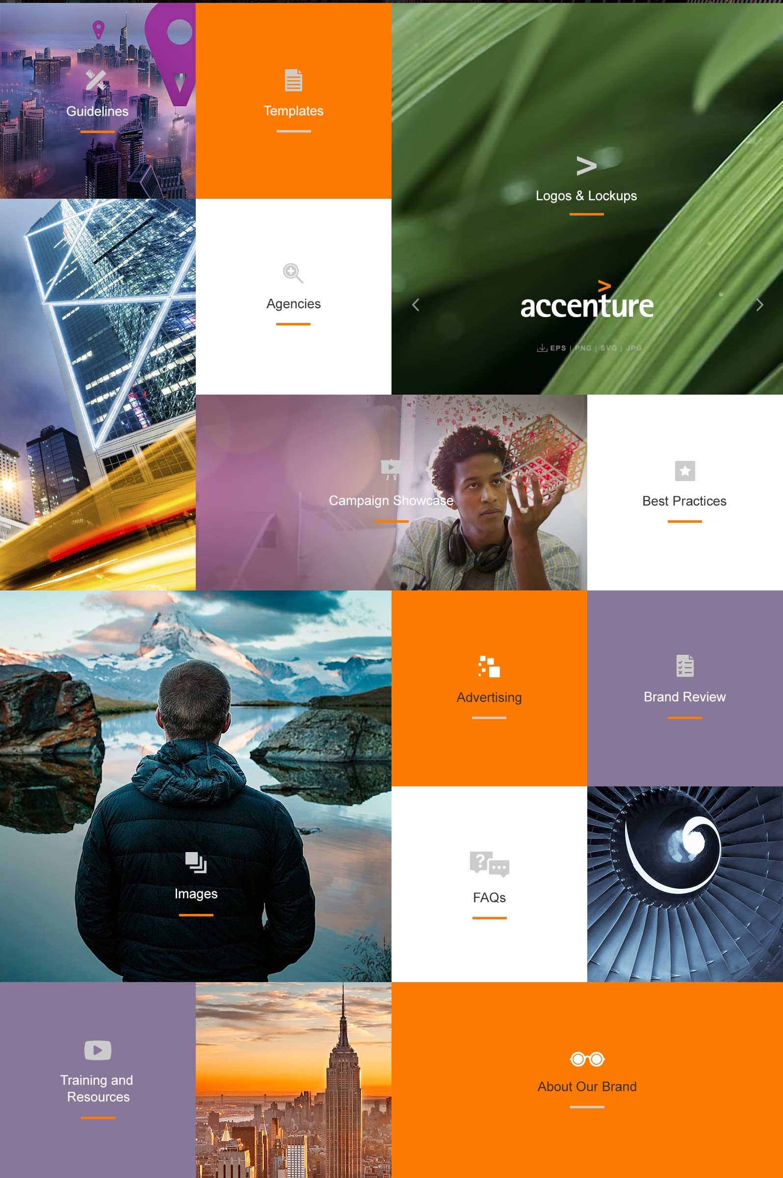

## Hover the tiles

* If the tile has background image, when hover it, background image changes to black & white, zoom to 120% size, one “VIEW AREA” button is shown on the top, click it will go to related page. Icon, title and orange line change to black and gray color.

|  |  |
| --- | --- |
| Normal | Hover |
|  |  |

* If the tile has background color, when hover it, background color changes to gray, one “VIEW AREA” button is shown on the top, click it will go to related page. Icon, title and orange line change to black and gray color

|  |  |
| --- | --- |
| Normal | Hover |
|  |  |

* When hover the “VIEW AREA” button, its background color changes to Orange  
  

## Fixed and dynamic background image

Only Campaign Showcase tile background image are pulled from recommended showcase pool randomly, so each time user will see different image.

For other tiles, their background image are fixed pictures.

## Tile’s link

Guidelines – Guidelines landing page  
Templates – Templates landing page  
Agencies – Agencies landing page  
Logos & Lockups – Downloads Artwork files page, in this section, there is also one carousel which has Accenture logos and lockups different format artwork files download link. Click left and right arrows will go to previous and next logo.  
Campaign Showcase – Campaign Showcase landing page  
Best Practices – Best Practices landing page  
Images – Download Images landing page  
advertising – Advertising Page  
Brand Review – Open a new email which will send to Global.Brand mail group  
FAQs – FAQs page  
Training and Resources – Training and Resources page  
About Our Brand – About Our Brand page

# AGENCY SPOTLIGHT CAROUSEL

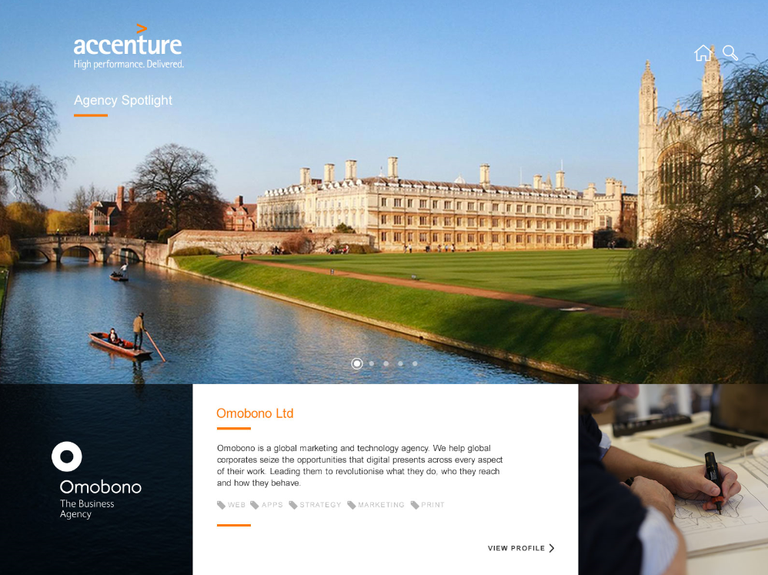

* This part should fill the whole screen
* Accenture logo, home and search icon should be displayed in this section
* Agencies data is pulled from recommended agencies pool. Brand team can choose which agencies are recommended
* Maximum display 5 recommended agencies in this carousel
* Click left and right arrow will go to previous and next agency information
* Information displayed here includes: hero image(background), logo, agency name, description, Specialties, image box which image is uploaded by agency user
* Click “VIEW PROFILE” link will go to agency detail page
* When hover specialties text and “VIEW PROFILE” link, color changes from black to orange

|  |  |
| --- | --- |
| Normal Style | Hover Style |
|  |  |

# BRAND SUPPORT PANEL

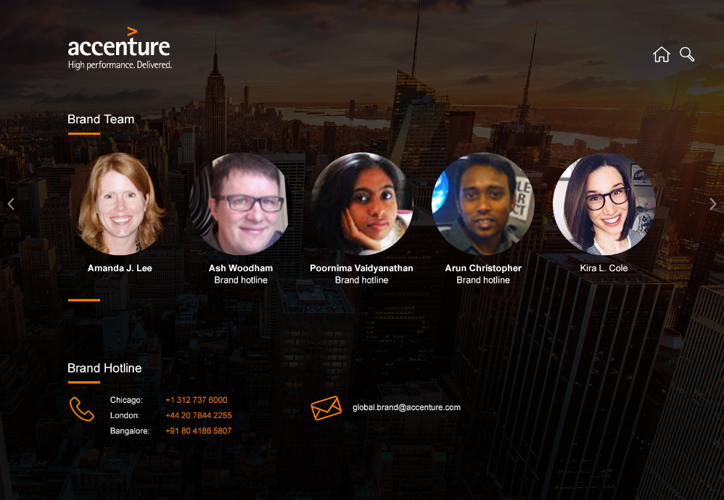

* This part should fill the whole screen
* Accenture logo, home and search icon should be displayed in this section
* Includes two parts: Brand Team members carousel and Hotline
* Click global brand support mailbox link will open a new email which will send to Global.Brand mail group
* Brand team carousel include member’s photo, name and team name
* Click left and right arrow will move one member out of the view and another new member move in
* When hover one brand team member, one orange color layer with an email icon will overlay on the member's photo, click it will open a new email which send to is this member's email address  
  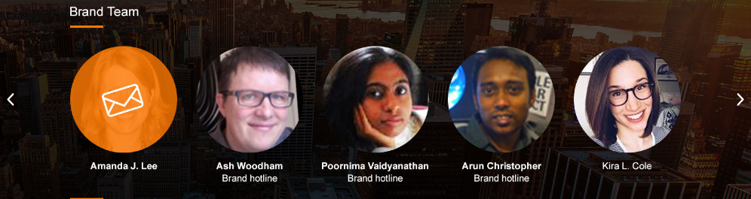

# WHAT ARE DIFFERENCES BETWEEN OUR WORK AND OMOBONO’S DESIGN

* We don’t have the three dots on the top right of each tile because it’s used for pin, share etcs and they are out of scope of initial launch
* For agency’s tile, Omobono’s design is when user hover the tile, will show search dropdowns as below  
  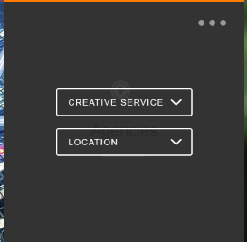  
  But to be consist with all other tiles, we will not have these dropdowns but show “VIEW AREA” button which will go to agencies landing page